Reinforced Learning - Reinforcement Learning is a powerful branch of Machine Learning. It is used to solve interacting problems where the data observed up to time t is considered to decide which action to take at time t + 1. It is also used for Artificial Intelligence when training machines to perform tasks such as walking. Desired outcomes provide the AI with reward, undesired with punishment. Machines learn through trial and error.

1. Upper Confidence Bound (UCB)
2. Thompson Scaling

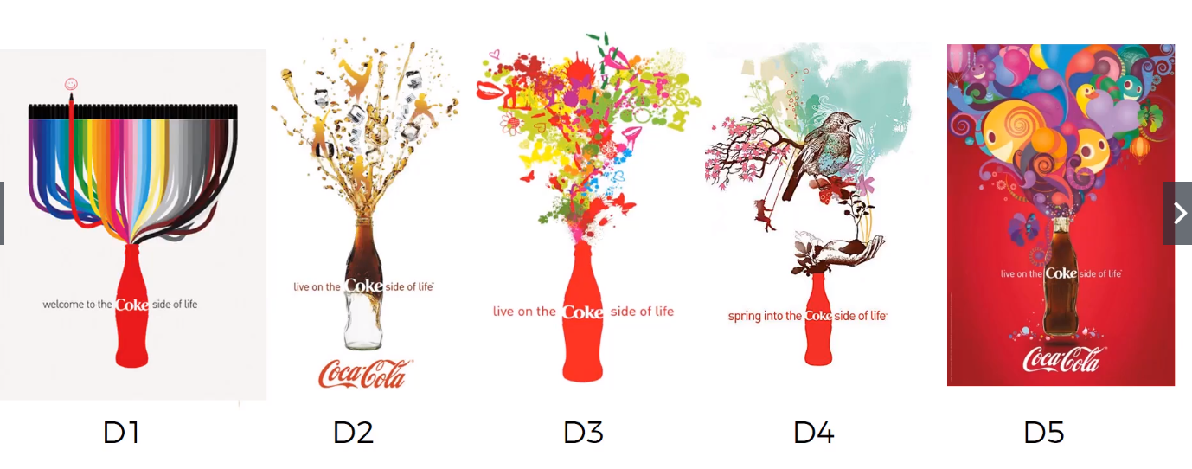Upper Confidence Bound (UCB) – Multi-Armed Bandit Problem. Casino Slots Machines. Each one of the machines has a distribution. It will tell you that you will lose based on the distribution. Need to see which of these distribution is the good for you. Need to know the highest confidence.

Run AB test for Exploration. To find out which is the best one while you are exploring for it. In the process of the actual launch Campaign.

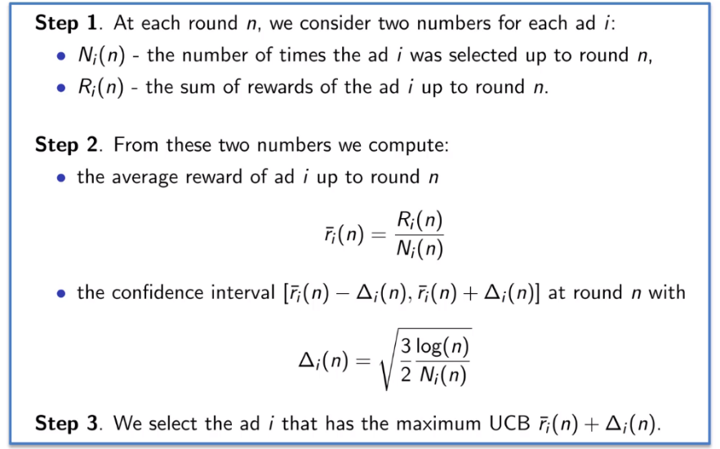Upper Confidence Bound (UCB) Intuition.

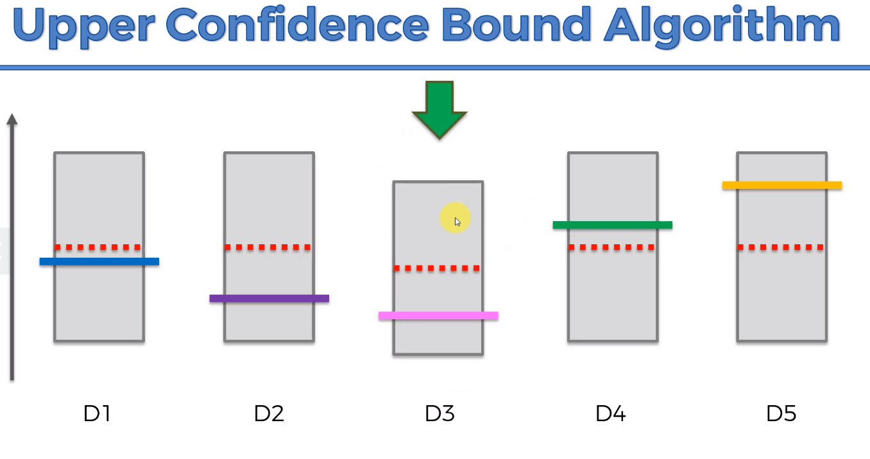For Every distribution, it assumes a starting point, Algorithm will create a confidence band, will include the actual expected return. First few rounds will be Trial Run, and Come up with the Confidence Bands and then we pick the one that has the Highest Confidence Band.

For the HIGHEST Confidence bound, and If you pull or display but didn’t click, the confidence band will go down and confidence interval will become smaller.

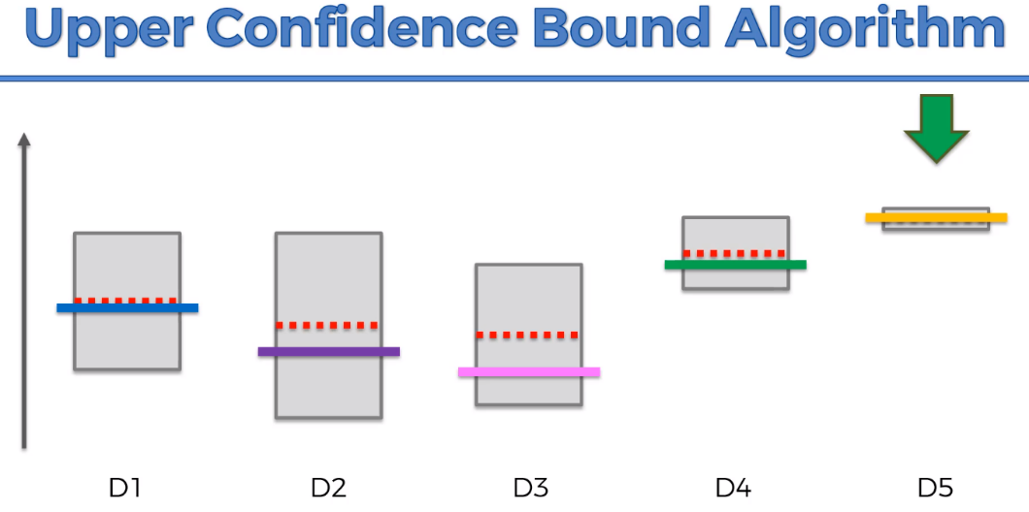Best Option will decrease the Confidence Bound.